DOI: 10.17129/botsci.2892
Supplementary Material
Figure S1. Graphical results of rarefaction analyses. Panels shows comparison for all studied plants (A) differentiating wild edible plantss (blue) and non-edibles (red). We also included analyses for each studied site: La Calera (B), Quillota (C), Limache (D), Quilpué (E), Valparaíso (F) and Placilla (G). For each panel, lines indicate rarefaction curves with values interpolated (continuous line) and extrapolated (dashed lines); points are observed richness and shaded area are 95% confidence intervals.
Species richness | - All plants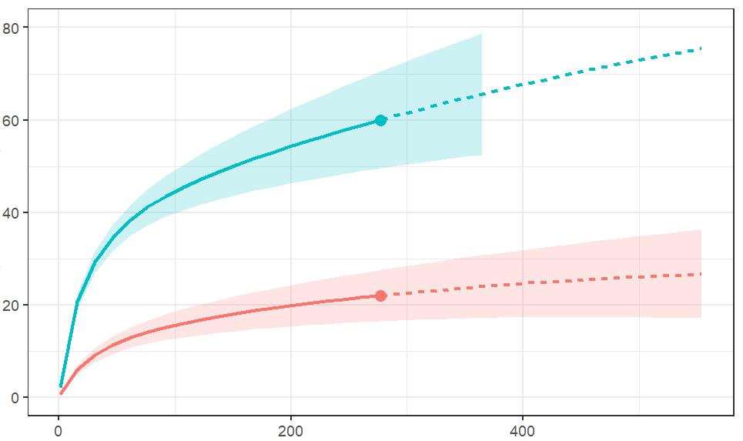 | (B) La Calera 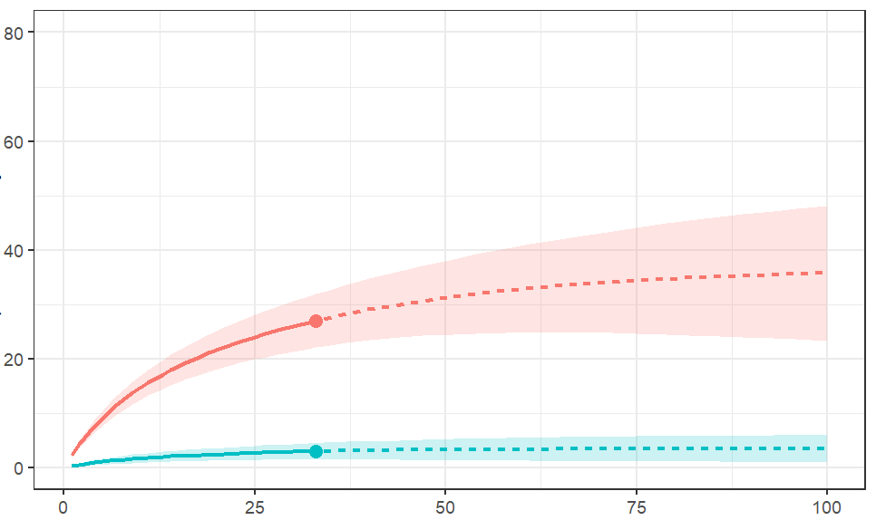
Species richness | (C) Quillota 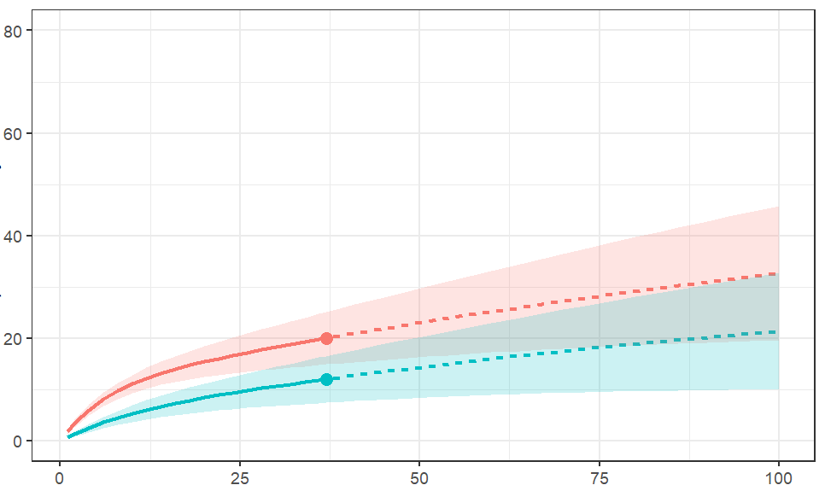 | (D) Limache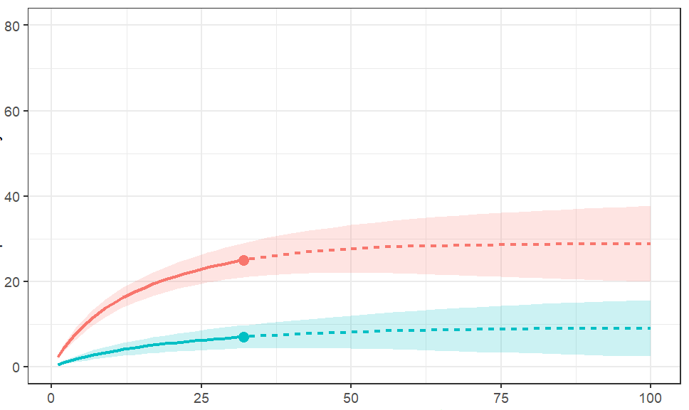
Species richness | (E) Quilpué  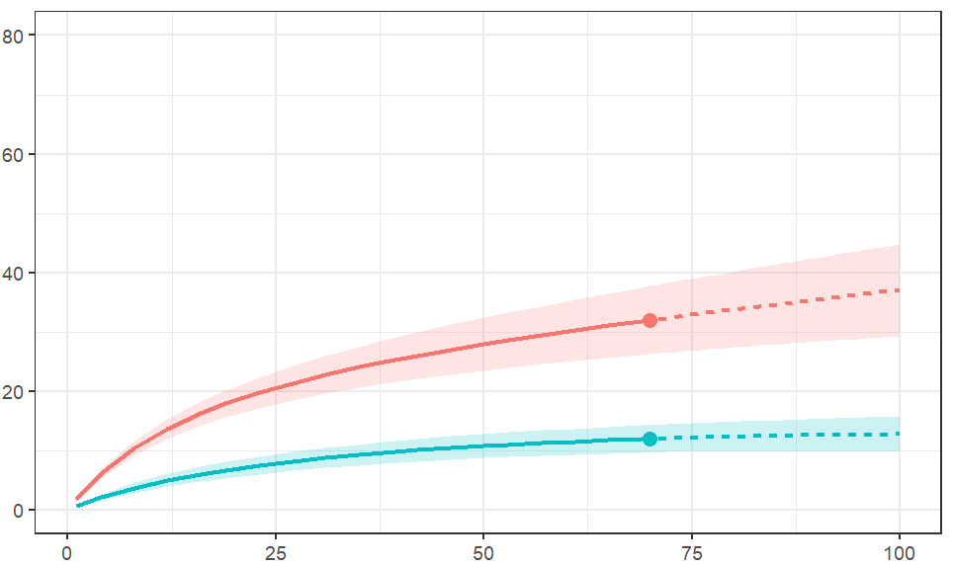 | (F) Valparaíso  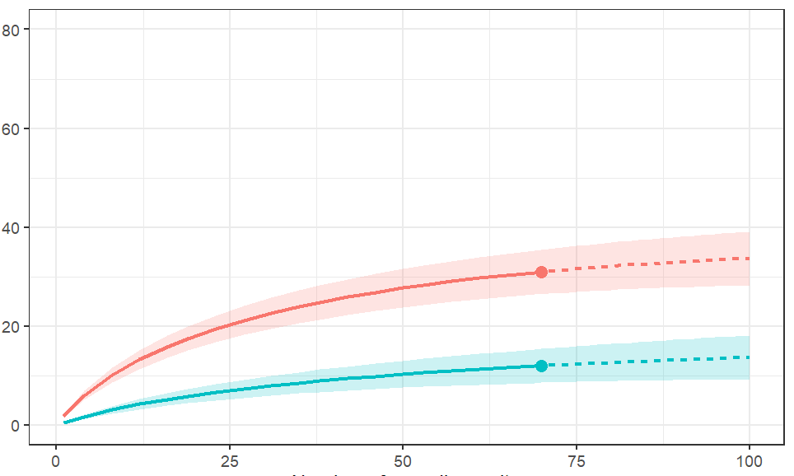
Species richness | (H) Placilla  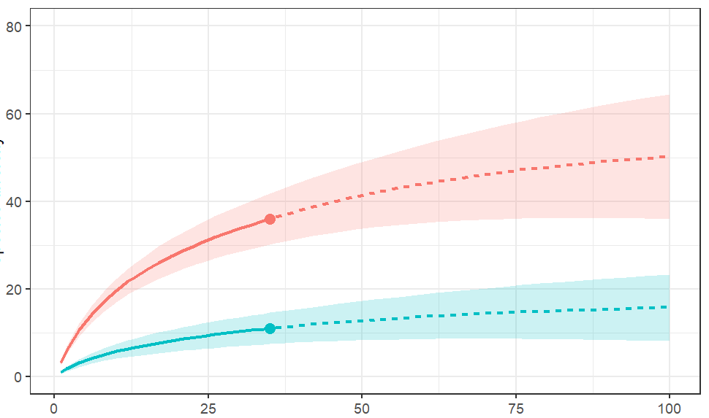
 | Number of plots

