Supplementary material
Table S1. Characteristics of species analyzed in this study. They are listed based on their pollination systems.

Species / Distribution | Family | Corolla type and symmetry | Sexuality | Pollination/ observation of visitors | Literature
Arbutus unedo L.  Ireland, N and SW Mediterranean; introduced to the Canaries, Madeira, New Zealand and Tasmania | Ericaceae | Urceolate  actinomorphic | Hermaphrodite | Bumblebees/bees | Rasmont et al. 2005, Ortega-Olivencia, Vélez & Rodríguez-Riaño unpubl. data
Teucrium fruticans L.  W & C Mediterranean | Lamiaceae | Unilabiate  zygomorphic | Hermaphrodite | Bumblebees/bees | Ortega-Olivencia, Vélez & Rodríguez-Riaño unpubl. data
Nicotiana glauca L.  S America from Bolivia to Brazil; introduced to N South America, C America, Africa, Mediterranean, Indian Peninsula and Australia | Solanaceae | Tubular-infundibuliform  actinomorphic | Hermaphrodite | Hummingbird species; out of place of origin passerines and lepidoptera; nectar stealing: Xylocopa and other hummingbirds | Grases & Ramírez 1998, Ollerton et al. 2012
Grevillea robusta A. Cunn. ex. R.Br.  E Australia; introduced to Italy, S Asia, N New Zealand, C and E Africa and America | Proteaceae | Tubular zygomorphic | HermaphroditeProtandry | (1) Honeyeaters (Meliphagidae) in its natural range; (2) nectarivorous birds, Kenya: Zosteropidae, Nectariniidae; (3) Sunbirds and Cape white-eye in S Africa; (4) Argentina: possible pollinating role for primates; (5) Steal nectar: ants and bees | (1) Lamont et al. 1985, Collins & Rebelo 1987 in Kalinganire et al. 2001, Kalinganire et al. 1996, (2) Brough 1933 in Kalinganire et al. 2001, Makinson 2000, Kalinganire et al. 2001, (3) Collins & Rebelo 1987 in Kalinganire et al. 2001, (4) Pavé et al. 2009, (5) Kalinganire et al. 2001
Species / Distribution | Family | Corolla type and symmetry | Sexuality | Pollination/ observation of visitors | Literature
Agave americana L.  S USA and Mexico; introduced to C and S America, Africa, Mediterranean, S Asia, E Australia and New Zealand | Agavaceae | Tubular (free tepals)  actinomorphic | Hermaphrodite  Protandry | (1) Bats, occasionally Sphingidae; (2) Canary Islands: 8 insectivorous birds as nectarivores, not as pollinators | (1) Howell 1972, Faegri & van der Pijl 1979, Gentry 1982, Rocha et al. 2006  (2) Rodríguez et al. 2015
Musa x paradisiaca L.  Malaysia; introduced to C America, C and E Africa, and S Asia | Musaceae | ± Tubular: 5 fused tepals + 1 free  zygomorphic | Hermaphrodite | (1) Bats, occasionally  birds or mammals; (2) Thief birds (2) | (1) van der Pijl 1956, Andersson 1998, Raghuram et al. 2011, Delucchi & Hurrell 2014, Pedrozo et al. 2018, Fuster et al. 2019; (2) Faegri & van der Pijl 1979
Cytinus hypocistis subsp  macranthus Wettst.  Iberian Peninsula and NW Africa | Cytinaceae | Tubular (male), lageniform (female)  actinomorphic | Unisexual  monoecious | Different ant species: Oplisa aterrima fly seeks nectar and secretions of glandular trichomes from the perianth | de Vega et al. 2009
C. ruber Fourr. ex Fritsch.  Mediterranean Region to W Caucasus | Cytinaceae | Tubular (male), lageniform (female)  actinomorphic | Unisexual  monoecious | Bees, few hoverflies  Doubt pollination by ants | Kugler (1977)
Aristolochia paucinervis Pomel  Macaronesia and Mediterranean | Aristolochiaceae | Tubular  zygomorphic | Hermaphroditeprotoginy | - Extremadura: Nematocera (7 genera); Brachycera (7 genera); (2) W Andalusia: 7 orders, the most common dipterans: Megaselia species (Phoridae) the main pollinators | (1) Pérez-Chiscano 2011; (2) Berjano et al. 2009
Species / Distribution | Family | Corolla type and symmetry | Sexuality | Pollination/ observation of visitors | Literature
Dianthus lusitanus Brot.  Iberian Peninsula and NW Africa | Caryophyllaceae | Caryophyllaceous  actinomorphic | Hermaphrodite | (1) Butterflies (Lycaena sp., Gonepteryx cleopatra); (1) Moths: Hadena compta; (2) Macroglossum stellatarum | (1) Ortega-Olivencia & Rodríguez-Riaño unpubl. data; (2) Prieto-Benítez et al. 2017
Cestrum nocturnum L.  C America and N South America; introduced to Caribbean islands, C and E Africa, S Asia, E Australia and N New Zealand | Solanaceae | Tubular  actinomorphic | Hermaphrodite | (1) Noctuidae (Plusiinae); (2) Noctuidae, Pyraustidae y Geometridae | (1) Heath et al. 1992; (2); Cuartas & Castaño 2008
Stellaria media (L.) Vill.  Temperate Eurasia, and N and NE tropical Africa; introduced to the rest of the world | Caryophyllaceae | c. Rosaceous  actinomorphic | Hermaphrodite | Exceptionally visits from Diptera, Hymenoptera, Thysanoptera at early spring | Müller 1883, Proctor & Yeo 1973, Cruden 1977, Laforest & Soufiane 2018
Distribution according to POWO 2023 Plants of the World Online. Facilitated by the Royal Botanic Gardens, Kew. Published on the Internet; http://www.plantsoftheworldonline.org/ (accessed 2022-2023).

Table S2. Eigenvalues of the first three principal components and total variance explained based on a categorical principal components analysis of eight qualitative and quantitative cell features of the adaxial face of the corolla lobes (ADAL).
 | Eigenvalues
 | C1 | C2 | C3 | Total
Cell projection | 0.906 | 0.071 | 0.003 | 0.980
Cell shape | 0.783 | 0.082 | 0.011 | 0.875
Cell surface | 0.000 | 0.863 | 0.000 | 0.863
Length-width | 0.419 | 0.448 | 0.000 | 0.867
Papillae +/- | 0.852 | 0.005 | 0.004 | 0.861
Papillae height | 0.824 | 0.003 | 0.029 | 0.857
Cell density | 0.113 | 0.050 | 0.672 | 0.835
Epidermal cell thickness | 0.273 | 0.068 | 0.345 | 0.686
% of variance explained | 52.127 | 19.878 | 13.302 | 85.306

Table S3. Eigenvalues of the first three principal components and total variance explained based on a categorical principal components analysis of 32 qualitative and quantitative features of adaxial and abaxial epidermal cells of the corolla and mesophyll thickness.
 | Eigenvalues
 | C1 | C2 | C3 | Total
Cell projection ADAT | 0.227 | 0.723 | 0.036 | 0.986
Cell projection ABAT | 0.227 | 0.723 | 0.036 | 0.986
Cell shape ADAT | 0.213 | 0.726 | 0.035 | 0.974
Papillae +/-ADAT | 0.213 | 0.726 | 0.035 | 0.974
Papillae +/-ADAL | 0.302 | 0.598 | 0.042 | 0.941
Height papillae ADAT | 0.198 | 0.690 | 0.041 | 0.929
Height papillae ADAL | 0.425 | 0.485 | 0.002 | 0.911
Cell projection ADAL | 0.219 | 0.676 | 0.009 | 0.905
Length-width ABAT | 0.101 | 0.004 | 0.719 | 0.823
Length-width ADAT | 0.129 | 0.000 | 0.687 | 0.817
Cell projection ABAL | 0.634 | 0.053 | 0.125 | 0.811
Papillae +/-ABAL | 0.578 | 0.016 | 0.170 | 0.764
Height papillae ABAL | 0.567 | 0.016 | 0.168 | 0.751
Cell surface ADAT | 0.011 | 0.654 | 0.014 | 0.678
Cell density ADAT | 0.479 | 0.146 | 0.036 | 0.661
Cell density ADAL | 0.016 | 0.001 | 0.589 | 0.605
Cell shape ADAL | 0.188 | 0.409 | 0.008 | 0.604
Cell density ABAT | 0.572 | 0.008 | 0.000 | 0.580
Tube mesophyll thickness | 0.064 | 0.267 | 0.243 | 0.574
Lobe mesophyll thickness | 0.231 | 0.061 | 0.260 | 0.552
Cell surface ABAL | 0.166 | 0.313 | 0.073 | 0.552
Cell shape ABAL | 0.134 | 0.069 | 0.332 | 0.536
Epidermal cell thickness ABAT | 0.436 | 0.011 | 0.073 | 0.520
Epidermal cell thickness ADAT | 0.375 | 0.012 | 0.112 | 0.498
Cell surface ADAL | 0.259 | 0.190 | 0.018 | 0.467
Length-width ADAL | 0.417 | 0.005 | 0.010 | 0.432
Epidermal cell thickness ABAL | 0.110 | 0.023 | 0.283 | 0.419
Cell density ABAL | 0.011 | 0.002 | 0.387 | 0.400
Length-width ABAL | 0.285 | 0.030 | 0.048 | 0.364
Epidermal cell thickness ADAL | 0.273 | 0.011 | 0.029 | 0.314
Cell shape ABAT | 0.050 | 0.073 | 0.037 | 0.159
Cell surface ABAT | 0.018 | 0.104 | 0.036 | 0.159
% of variance explained | 25.400 | 24.445 | 14.677 | 64.522

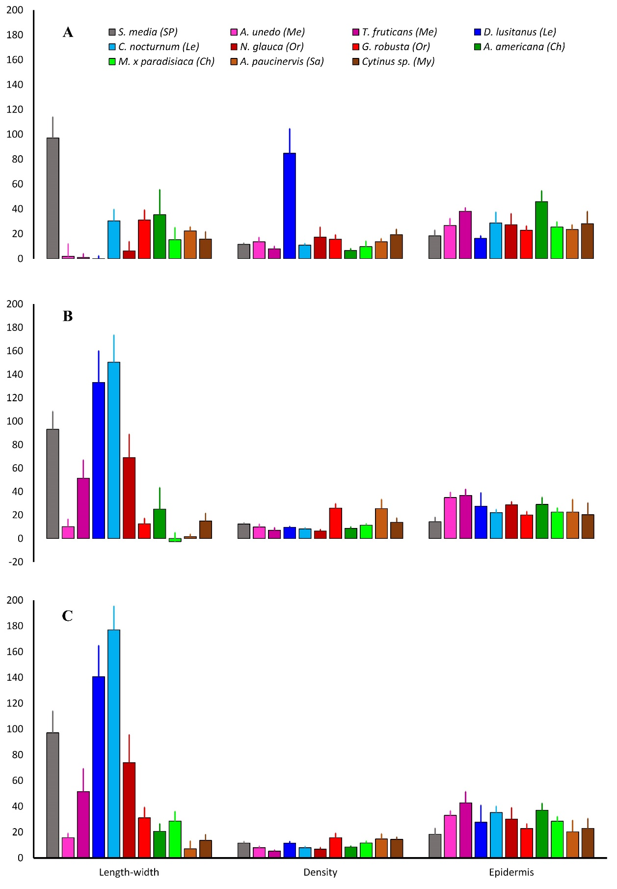
Figure S1. Analyzed quantitative variables (mean ± SD) of the (A) abaxial side of the corolla lobes (ABAL), (B) adaxial side of the corolla tube (ADAT), and (C) abaxial side of the corolla tube (ABAT). The following variables were analyzed: length-width (length − width, in µm), density (cells/100 µm²), and epidermis (epidermal cell thickness, in µm). Ch, chiropterophily; Le, lepidopterophily; Me, melittophily; My, myrmecophily; Or, ornithophily; Sa, sapromiophily; SP, widespread self-pollination.
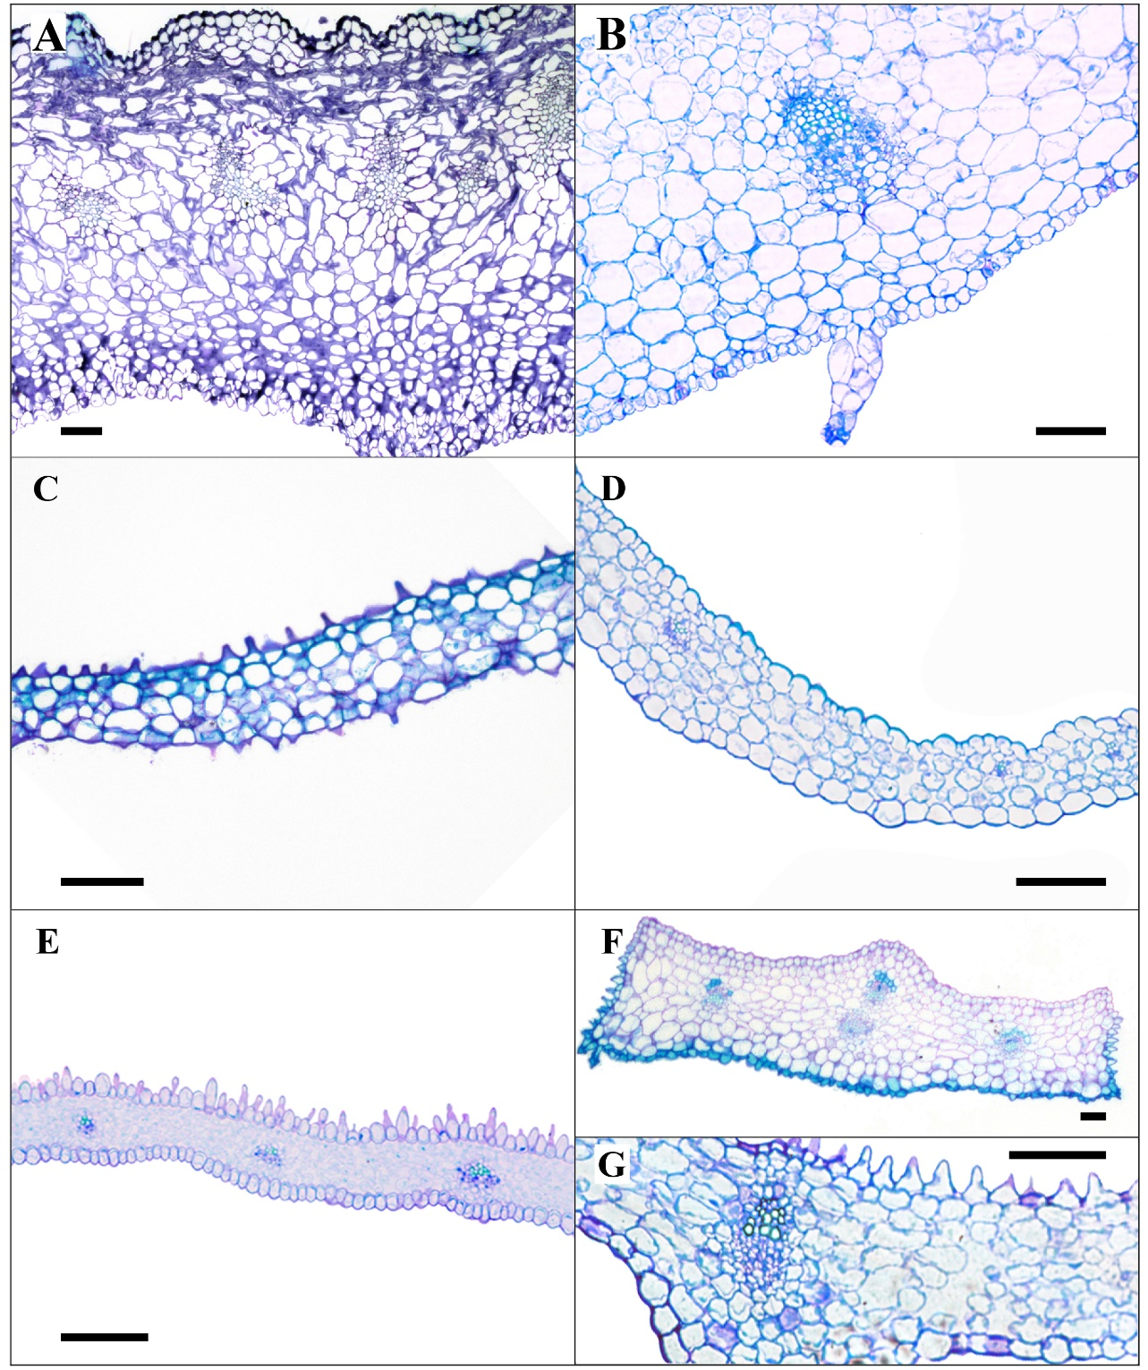
Figure S2. Histological sections of the corolla tube from some of the studied species. A. Agave americana (chiropterophily). B. Cytinus hypocistis subsp. macranthus (myrmecophily). C. Arbutus unedo (melittophily. D. Stellaria media (widespread self-pollination). E. Dianthus lusitanus (lepidopterophily). F. Grevillea robusta (ornithophily). G. Aristolochia paucinervis (sapromiophily). Upper part of each image corresponds to the adaxial face. Scale bar = 100 µm.

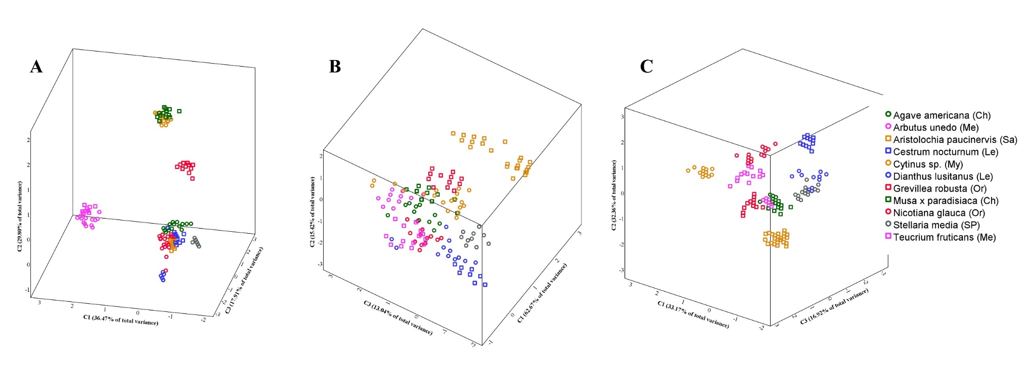
Figure S3. Tri-dimensional CATPCA plots. A. Abaxial epidermal cells of the corolla lobes (ABAL; total variance = 84.18 %). B. Abaxial epidermal cells of the corolla tube (ADAT; total variance = 91.13 %). C. Abaxial epidermal cells of the corolla tube (ABAT; total variance = 82.44 %). Ch, chiropterophily; Le, lepidopterophily; Me, melittophily; My, myrmecophily; Or, ornithophily; Sa, sapromiophily; SP, widespread self-pollination.

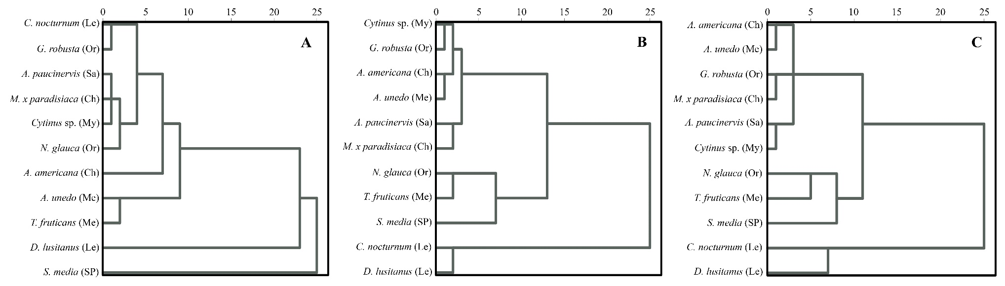
Figure S4. Cluster dendrograms generated using the SPSS Baverage method based on Euclidean distance. A-C. Dendrograms based on qualitative and quantitative features of (A) abaxial epidermal cells of corolla lobes (ABAL), (B) adaxial epidermal cells of the corolla tube (ADAT), and (C) abaxial epidermal cells of the corolla tube (ABAT). Ch, chiropterophily; Le, lepidopterophily; Me, melittophily; My, myrmecophily; Or, ornithophily; Sa, sapromiophily; SP, widespread self-pollination.

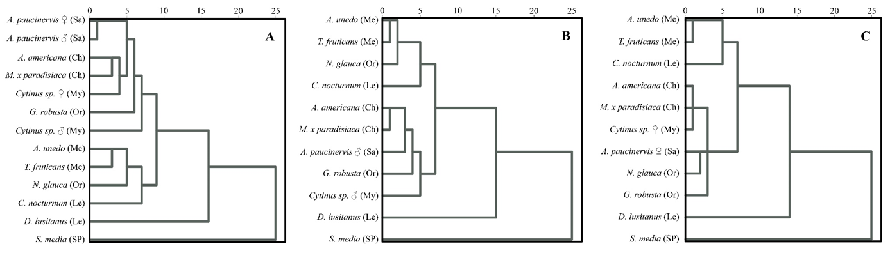

Figure S5. Cluster dendrograms generated using the SPSS Baverage method based on Euclidean distances between qualitative and quantitative features of adaxial epidermal cells of corolla lobes (ADAL). A-C. Dendrograms taking into account (A) both female and male phases/flowers of Aristolochia paucinervis and Cytinus sp., (B) only male flowers, and (C) only female flowers. Ch, chiropterophily; Le, lepidopterophily; Me, melittophily; My, myrmecophily; Or, ornithophily; Sa, sapromiophily; SP, widespread self-pollination.

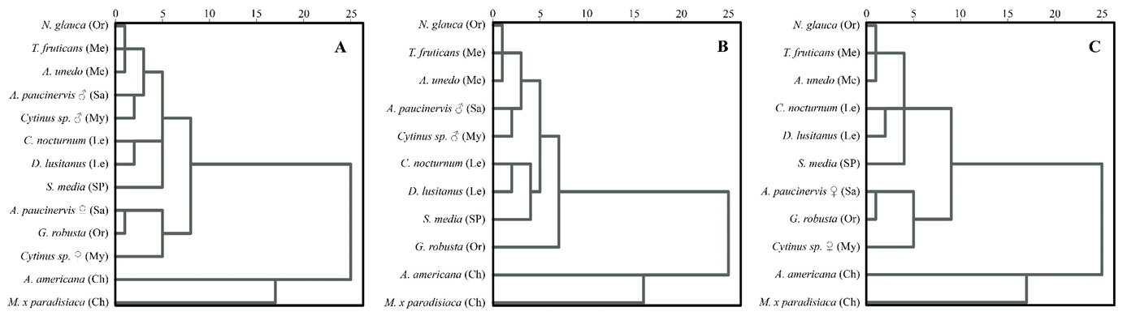

Figure S6. Dendrograms obtained from clustering analysis by Baverage’s method based on Euclidean distance considering qualitative and quantitative features of the adaxial and abaxial epidermal cells of the corolla lobes and the corolla tube, and mesophyll thickness of both zones of the corolla. A. From both female and male phase/flower of Aristolochia paucinervis and Cytinus sp. B. Only from male flowers. C. Only from female flowers. Ch, chiropterophily; Le, lepidopterophily; Me, melittophily; My, myrmecophily; Or, ornithophily; Sa, sapromiophily; SP, widespread self-pollination.

Literature cited

Andersson L. 1998. Musaceae. In: Kubitzki K, ed. The Families and Genera of Vascular Plants. Vol. 4. Belin: Springer-Verlag, pp 296-301. ISBN: 13: 9783540640615

Berjano R, Ortiz PL, Arista M, Talavera S. 2009. Pollinators, flowering phenology and floral longevity in two Mediterranean Aristolochia species, with a review of flower visitor records for the genus. Plant Biology 11: 6-16. DOI: https://doi.org/10.1111/j.1438-8677.2008.00131.x
Cuartas Y, Castaño E. 2008. Descripción botánica y fitoquímica del jazmín de noche (Cestrum nocturnum L.). Boletín Científico del Museo de Historia Natural 12: 17-23.

Cruden RW. 1977. Pollen-ovule ratios: a conservative indicator of breeding systems in flowering plants. Evolution 31: 32-46. DOI: https://doi.org/10.1111/j.1558-5646.1977.tb00979.x

Delucchi G, Hurrell J. 2014. Musaceae. In: Hurrell JA, ed. Flora Rioplatense: sistemática, ecología y etnobotánica de las plantas vasculares rioplatenses. Vol. 3. La Plata: Facultad de Ciencias Naturales y Museo, Universidad Nacional de La Plata, pp: 253-262. ISBN: 9871533020, 9789871533022.

de Vega C, Arista M, Ortiz PL, Herrera CM, Talavera S. 2009. The ant-pollination system of Cytinus hypocistis (Cytinaceae), a Mediterranean root holoparasite. Annals of Botany 103: 1065-1075. DOI: 10.1093/aob/mcp049

Faegri K, van Der Pijl L. 1979. The principles of pollination ecology. Oxford: Pergamon. ISBN: 0-08-021338-3

Fuster F, Kaiser-Bunbury Ch, Olesen JM, Traveset A. 2019. Global patterns of the double mutualism phenomenon. Ecography 42: 826-835. DOI: https://doi.org/10.1111/ecog.04008

Gentry HS. 1982. Agaves of Continental North America. Tucson: The University of Arizona Press. ISBN: 13: 9780816523955

Grases C, Ramírez N. 1998. Biología reproductiva de cinco especies ornitófilas en un fragmento de bosque caducifolio secundario en Venezuela. Revista de Biología Tropical 46: 1095-1108

Heath RR, Landolt PJ, Dueben B. 1992. Identification of floral compounds of night-blooming Jessamine attractive to cabbage looper moths. Environmental Entomology 21: 854-859

Howell DJ. 1972. Physiological adaptations in the syndrome of chiropterophily with emphasis on the bat, Leptonycteris Lydekker. PhD Thesis. University of Arizona

Kalinganire A, Harwood CE, Simons AJ, Moncur MW, Slee MU. 1996. Reproductive ecology of Grevillea robusta in western Kenya. In: Dieters MJ, Matheson AC, Nikles DG, Harwood CE, Walker SM, eds. Tree Improvement for Sustainable Forestry. Caloundra, Queensland: QFRI-IUFRO Conference.

Kalinganire A, Harwood CE, Slee MU, Simons AJ. 2001. Pollination and fruit-set of Grevillea robusta in western Kenya. Austral Ecology 26: 637-648. DOI: https://doi.org/10.1046/j.1442-9993.2001.01139.x

Kugler H. 1977. Zur Bestäubung mediterraner Frühjahrsblüher. Flora 166: 43-63. DOI: https://doi.org/10.1016/S0367-2530(17)32109-6

Laforest M, Soufiane B. 2018. Coevolution of two sulfonylurea-resistant common Chickweed (Stellaria media) biotypes with different mutations in the acetolactate synthase gene. Weed Science 66: 439-445. DOI: https://doi.org/10.1017/wsa.2018.26

Lamont BB, Collins BG, Cowling RM. 1985. Reproductive biology of the Proteaceae in Australia and southern Africa. The Proceeding of the Ecological Society of Australia 14: 213-224.

Makinson RO. 2000. Grevillea. In: Orchard A, Thompson H, McCarthy P, Wilson A, eds. Flora of Australia. Vol. 17A. Canberra: Australian Biological Resources Study. ISBN: 0 643 05969 5

Müller H. 1883. The fertilization of flowers. London: MacMillan. ISBN: 1362238112

Ollerton J, Watts S, Connerty S, Lock J, Parker L, Wilson I, Schueller SK, Nattero J, Cocucci AA, Izhaki I, Geerts S, Pauw A, Stout JC. 2012. Pollination ecology of the invasive tree tobacco Nicotiana glauca: comparisons across native and non-native ranges. Journal of Pollination Ecology 9: 85-95. DOI: https://doi.org/10.26786/1920-7603(2012)12

Pavé R, Peker SM, Raño M, Ramírez CR, Zunino GE, Kowalewaki MM. 2009. Nectar feeding on an exotic tree (Grevillea robusta) by Alouatta caraya and its possible role in flower pollination. Neotropical Primates 16: 61-64. DOI: https://doi.org/10.1896/044.016.0203

Pedrozo AR, Gomes LA, Uleda W. 2018. Feeding behavior and activity period of three Neotropical bat species (Chiroptera: Phyllostomidae) on Musa paradisiaca inflorescences (Zingiberales: Musaceae). Ilheringia, Série Zoologia 108: e2018022. DOI: https://doi.org/10.1590/1678-4766e2018022

Pérez-Chiscano JL. 2011. Relaciones entre pequeños dípteros y flores de Aristolochia paucinervis Pomel y Aristolochia pistolochia L. (Aristolochiaceae) en Extremadura (España). Folia Botanica Extremadurensis 5: 29-36.

Prieto-Benítez S, Yela JL, Giménez-Benavides L. 2017. Ten years of progress in the study of Hadena-Caryophyllaceae nursery pollination. A review in light of new Mediterranean data. Flora 232: 63-72. DOI: https://doi.org/10.1016/j.flora.2017.02.004

Proctor M, Yeo P. 1973. The pollination of flowers. London: Collins. ISBN: 0002131781

Raghuram H, Singaravelan N, Nathan PT, Ravan KE, Marimuthu G. 2011. Foraging ecology of pteropodid bats: pollination and seed dispersal. In: Jakob L, Zupan JL, Mlakar SL, eds. Bats: Biology, Behavior and Conservation. Chapter 4. Hauppauge, Nueva York: Nova Science Publisher, Inc. ISBN: 978-1-61209-749-7

Rasmont P, Regali A, Ings TC, Lognay G, Baudart E, Marlier M, Delcarte E, Viville P, Marot C, Falmagne P, Verhaeghe J, Chittka L. 2005. Analysis of pollen and nectar of Arbutus unedo as a food source for Bombus terrestris (Hymenoptera: Apidae). Journal of Economic Entomology 98: 656-663.

Rocha M, Good-Ávila SV, Molina-Freaner F, Arita HT, Castillo A, García-Mendoza A, Silva-Montellano A, Gaut BS, Souza V, Eguiarte LE. 2006. Pollination biology and adaptive radiation of Agavaceae, with special emphasis on the genus Agave. Aliso 22: 329-344.

Rodríguez B, Siverio F, Siverio M, Barone R, Rodríguez A. 2015. Nectar and pollen of the invasive century plant Agave americana as a food resource for endemic birds. Bird Study 62: 232-242. DOI: https://doi.org/10.1080/00063657.2015.1015484

van der Pijl L. 1956. Remarks on pollination by bats in the genera Freycinetia, Duabanga and Haplophragma, and on chiropterophily in general. Acta Botanica Neerlandica 5: 135-144. DOI: https://doi.org/10.1111/j.1438-8677.1956.tb00548.x

